**MODEL BASED REINFORCEMENT LEARNING**

**With On-Policy Data Collection and Ensemble Bootstrapping**

**MODEL BASED REINFORCEMENT LEARNING**

**With On-Policy Data Collection and Ensemble Bootstrapping**



After 1 iteration After 18 iteration

Model Based Reinforcement learning (MBRL) consists primarily of two aspects: (1) learning a dynamics model and (2)using the learned dynamics models to plan and execute actions that minimize a cost function (or maximize a reward function).

(*In this work, we assume access to the underlying reward function, which we use for planning actions under the learned model.)

1>Learning Dynamics Model

Instead of learning next state we would learn the change in state instead :

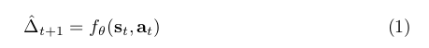

such that:



why to train network to predict state differences, instead of directly predicting next state?

:The functions where we learn the next state from current state-action pair can be difficult to learn when the states s t and s t+1 are too similar and the action has seemingly little effect on the output;this difficulty becomes more pronounced as the time between states ∆t becomes smaller and the state differences do not indicate the underlying dynamics well.

We cannot increase the ∆t much as ∆t also increases the discretization and complexity of the

underlying continuous-time dynamics, which can make the learning process more difficult.

The training is done on data set comprising of s(t+1)-s(t) labels in a general supervised learning with stochastic gradient descent method; loss function is defined as follows:

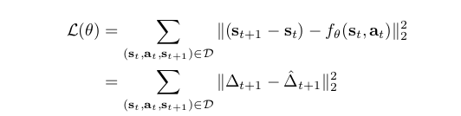

2>Action Selection

After learned dynamics the next task is to somehow choose “actions sequence” which would maximize the return

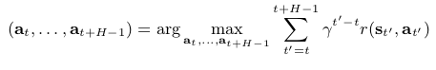

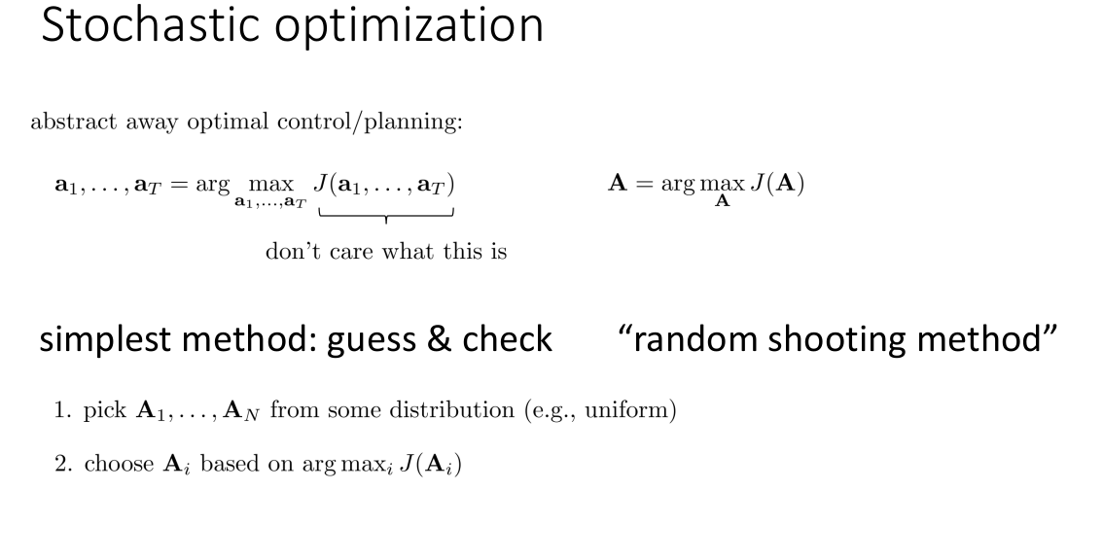

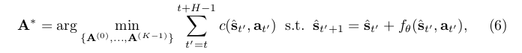

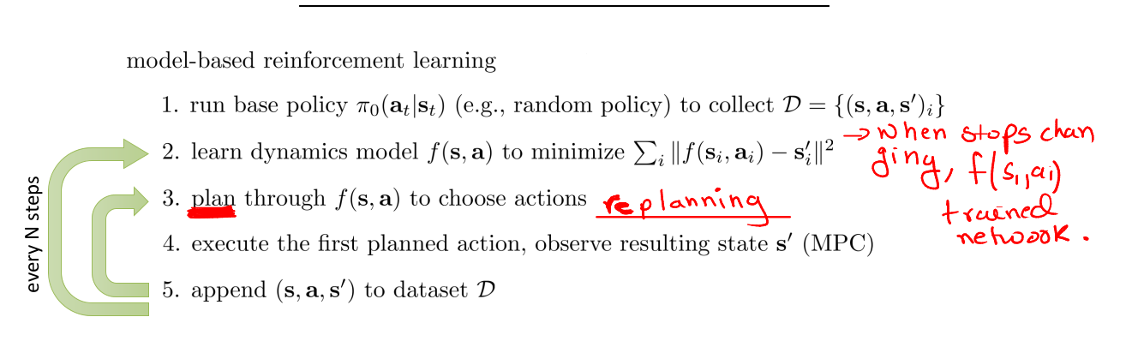General Model Based Reinforcement learning algorithm with on policy data collection something similar to DAGGER in imitation learning;

MBRL algorithm with Random Shooting method for planning:

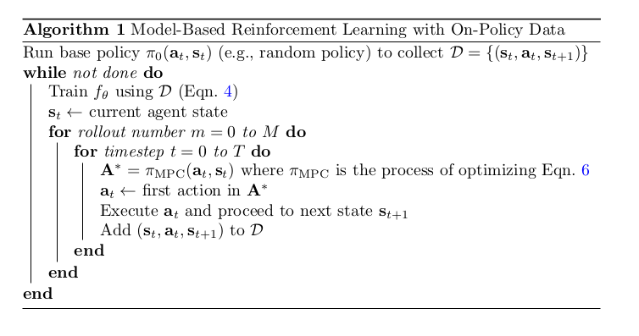

**ALGORITHM IMPLEMENTED IN THIS WORK IS AS FOLLOWS:**

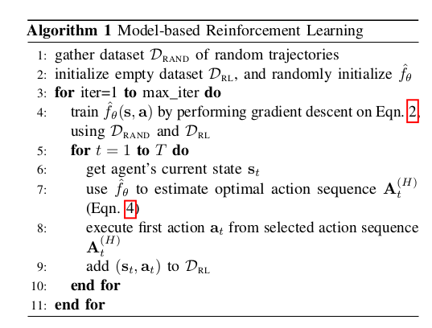

1.Same as above except for some fixed iteration (max_iter)

2.not stochastic gradient descent but mini batch (with train_batch_size)

3.number of gradient steps to optimize in this work is also fixed ( num_agent_train_steps_per_iter

)

*eqn2=Loss function as defined above

*eqn4 same as eqn6